PROJECT DESIGN PHASE – 2
Solution Architecture
Date | 30 September 2026
Team ID | SWTID-2026-2597
Project Name | Streamlining IT Procurement – Automating Standard Laptop Orders with Flow Designer
Team Leader | SANTHIYA M
Maximum Marks | 4 Marks

Team Members
- SRIDHARSHINI T
- SARAL NILA M
- ROSHINI R / RITHIKA S
Solution Architecture
The proposed architecture bridges the IT procurement problem and the ServiceNow technology solution. The Service Catalog request starts the workflow, Flow Designer creates the required Catalog Task, and the Hardware team performs laptop configuration.
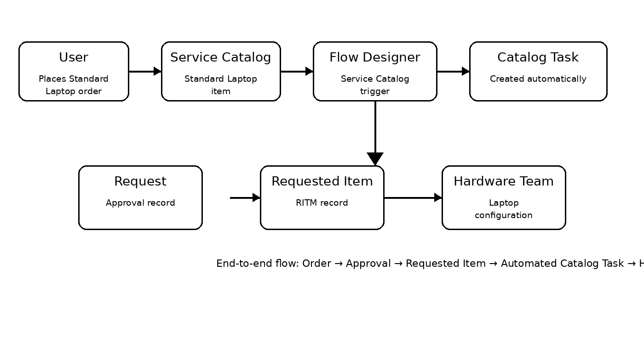
Figure 1. Solution architecture and data flow for automated Standard Laptop procurement.
Key Components
Component | Purpose
Service Catalog | Provides the Standard Laptop catalog item and captures the user request.
Service Catalog Trigger | Starts the Flow Designer flow when the configured catalog process is triggered.
Flow Designer | Automates the process without manual task creation.
Requested Item (RITM) | Stores the individual Standard Laptop request details.
Catalog Task (sc_task) | Created by the flow with the required description, approval and assignment group.
Hardware Assignment Group | Receives the task and performs laptop configuration.
Architecture Outcome
The architecture provides a consistent automated path from the Standard Laptop request to Hardware task assignment, reducing manual handoffs and supporting faster configuration.

Reference Template
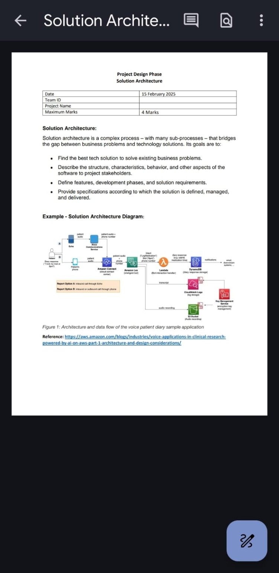
Reference: Solution Architecture template supplied for the project.

